Bury Older Peoples Network Action Plan 2025-2026
The Bury Older People’s Network is a forum for older people to have their voices heard on things that matter to them and to influence how services are designed, commissioned, and delivered. The ultimate aim is to create better outcomes for older residents in Bury.
The BOPN and the Older People and Ageing Well Steering Group will oversee the action plan to ensure it progresses and achieves positive change.
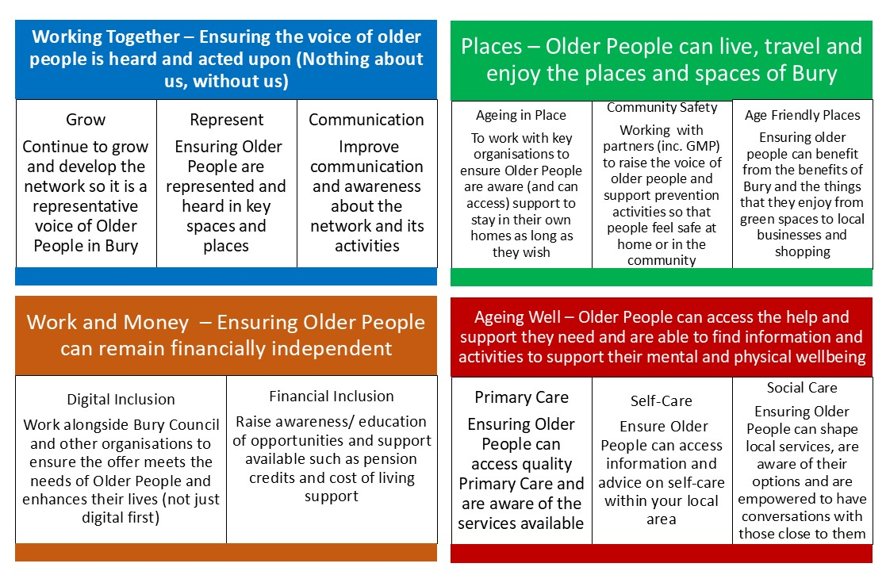
- Working Together – Ensuring the voice of older people is heard and acted upon (Nothing about us, without us)

 | Area of Work | What | Who | When | Progress so far
Governance | Regular effective meetings of the Bury Older Peoples Network including appropriate representation of the older people of Bury | At least 10 meetings or events per year to take place | BOPN / VCFA | Ongoing | Monthly meetings/events scheduled except in August & December (Holidays).  Annual Away Day - January
Governance | Associate membership for VCSE Organisations | Associate membership to the network to enable organisations to:  - Identify a key representative  - Champion and cascade information (including sharing and promoting the minutes) to those unable to attend. | BOPN/ VCFA | Spring 2025 | Note, that associate members are welcome to attend as and when relevant but must not overpower the voice of core members
Represent | Ensuring continued ownership and leadership of the BOPN by the network members | Ensuring leadership, ownership, and representation within the network | Network Members | Spring 2025 | Chair – Joanna Mawdsley  Need to look at additional roles – reps / vice chair/ minute taker
Represent | Civic Participations – voice and reps on other networks and forums | Ensuring representation from the network on key Bury and GM Forums | Network Members | Ongoing | Current representatives on other groups include Social Care Future, GM Older Peoples Network and Bury LGBTQI+ Forum
 |  | Bury Age Friendly Strategy Consultation – support and insight | BOPN / VCFA & Bury Council | Spring / Summer 2025 | Awaiting details of the consultation.  Connected with Social Care Futures insight.
Communication | Development and maintenance of BOPN Online presence | Website maintenance and social media presence | BOPN / VCFA | Ongoing | Basic webpage hosted on the VCFA website is updated monthly, including minutes etc.  Regular assets produced promoting the network  Facebook page under development
Communication | Develop and maintain physical marketing materials to support the network | Postcards and materials for events  Maintain an awareness of events that members may attend | BOPN / VCFA | Ongoing | Postcards and promotional pens produced

- Places – Older People can travel and enjoy the places and spaces of Bury

 | Area of Work | What | Who | When | Progress so far
Ageing in Place | Care at home contract – re-tender | Need for the network's voice and experience to help shape the commission | BOPN / BC | Spring 25 | Joanna Mawdsley is part of the co-design process for the tender specification.
Age-Friendly Places | Bury Aging in Place Pathfinder Project - Support and Expand | To support the continued work and expansion of the Bury Aging in Place Pathfinder Project currently in Moorside | Persona / BC/ BOPN | Ongoing | Joanna Mawdsley is on the project board, Steven Greason (AIP Project Manager) is invited to the BOPN
Age-Friendly Places | Practical support to ensure older people can be “out and about” | Support the expansion and quality assurance of the “take a seat” initiative | BOPN / BC Public Health | By Winter 2025 | Communication and promotion / to develop a mystery shopping audit of current provider to see if they actually offer a positive experience.  Support Bury Council and public health partners to ensure effective benches in public spaces to support older people.  Increase awareness of RADAR keys and how to access them
Age-Friendly Places | Safe, accessible and affordable transport options | Ensure the voice of older people is reflected as the Bee Network and GM Transport Strategy is delivered across the borough. | BOPN / BC/ TfGM | Ongoing | Engagement with TfGM has been mixed and exploring further connection alongside the GM Older Persons Network.  Ensure conversations around “Ring and Ride” services are included in the conversation,  Build closer links to Bury disabled people organisations to ensure unified voice as issues often overlap.
Community Safety | Ensuring older people feel safe in their homes and in their community (including public transport) | Engagement with the Bury Community Safety Strategy refresh and delivery. | BOPN / BC / GMP / Partners | Ongoing | Joanna Mawdsley part of Community Safety Cohesion Group
Community Safety |  | Ongoing engagement with GMP with the network to raise awareness or concerns but also how residents can get engage | BOPN / BC / GMP / Partners | Spring 2025 | GMP to be invited to the March meeting but also has connection to neighbourhood PACT awareness / Bee in the Loop etc

- Work and Money – Ensuring Older People can remain financially independent (This may be improved employment, increased awareness of benefit entitlements, financial security in retirement or ensuring access to digital technology etc)

 | Area of Work | What | Who | When | Progress so far
Digital Inclusion | Work alongside Bury Council and other organisations to ensure the offer meets the needs of Older People | Work with the new digital inclusion engagement officer to ensure the development of an age-friendly offer borough-wide | BOPN / BC | Ongoing | Bury Council Digital Inclusion officer has been invited to BOPN meetings  Consider how to raise awareness of non-digital methods of contacts for key services so that people are not excluded
Digital Inclusion |  | Ensure that older people are aware of technology can improve their lives e.g. assistive technology. | BOPN / BC | This work is yet to be started | Session hosted with Bury Blind Society and BC re options available in assistive technology.
Financial Inclusion | Raise awareness/ education of older people rights, opportunities and offers such as attendance allowance, pension credits and cost of living support | Increase awareness of the support available – Age UK information and Advice, CAB, Food Pantries, Other Services | BOPN/ BC / CAB / Age UK / Other services | Ongoing

- Ageing Well – Older People can access the help and support they need and are able to find information and activities to support their mental and physical wellbeing

 | Area of Work | What | Who | When | Progress so far
Primary Care | Ensuring Older People can access quality Primary Care and are aware of the services available | Member awareness of current situation on how to access GPs and Primary Care (including pharmacy, dentistry, social prescribing, and community health services). Working in partnership with Healthwatch - building on their reports to improve access to services | BOPN / GM NHS / Bardoc / GP Federation / Healthwatch | Ongoing | Healthwatch has presented on topics such as the NHS App  GP appointment booking – the variety of service/quality raised as a possible area to explore further
Self-Care | Information on local services and support offers | Make better use of the Bury Directory and explore feasibility/ funding to develop a physical booklet | BOPN/ VCFA/ BC (Public Health) | Ongoing | A key services leaflet was designed and printed – build on this potentially using the five ways to wellbeing as a framework.  Planning for the future: Make your own decisions. Conversations with family should be included in any potential booklet or directory.  BOPN engaged in user testing for the new adult social care website and Bury Directory improvements
Self-Care | Active Ageing | Ensure older people are support and encourage to be physical activity for both mental and physical wellbeing | BOPN / BC Staying Well / BC Live Well / GM Moving | TBC Work not yet started – new piece of work | This is not just fall prevention and chair-based activity but the broader physical activity offer for older people
Social Care | Ongoing codesign and co- production of key services development and changed. | As mentioned above the network is already involved at the Care at Home tender – ensuring this work continues as services evolve or are tendered / retendered | BOPN / Bury Council | This work is yet to be started | Extra Care Housing Strategy in the pipeline with timeline tbc
Social Care | Workforce training and support | Supporting the social care workforce to be more age aware and be able to signpost to broader services available | BOPN / BC / Staying Well / Bury Health System / VCSE orgs / Private business | This work is yet to be started | Potential this may be resolved by the leaflet above.
Social Care | Support Bury CQC Inspection | Be available to engage with inspectors to talk about experiences as a network / individual | BOPN/ VCFA/ BC | Feb 25  Ongoing | BOPN part of the lived experience interviews for the LGA Audit.

